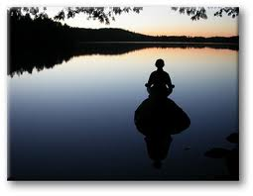

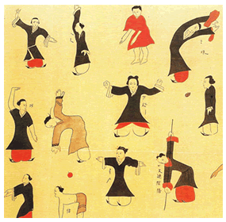
A 6 week introductory course to the ancient practice of Qigong , meaning ‘cultivating energy’, that aligns the breath with movement and awareness for exercise, healing, and meditation.

Starting Monday,7th October 2013 at Eastbourne’s Natural Fitness Centre on the seafront.
The course will run every Monday for 6 weeks from 4.45pm -5.45 pm. Open to all ages and abilities. Drop in £7 per session or £35.00 for 6 week course. Booking advisable.
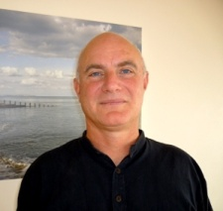
We will be exploring the power of the breath with gentle, flowing movements and stillness, connecting with our own energy and that of nature, based around the Five Elements of Chinese Medicine. Qigong is also a path to greater self awareness and understanding of our true nature. Meditation has been practiced for thousands of years and can be done by people of all faith traditions. With the practice of meditation the mind settles and a sense of ease, tranquillity and joy arise. This can also lead to insight and wisdom.
Course leader is Nick Neter MRSS Dip QT who is Shiatsu Practitioner and Qigong Teacher.
Website: www.eastbourneshiatsu.co.uk Tel:07773061309

