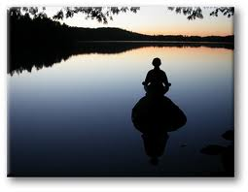

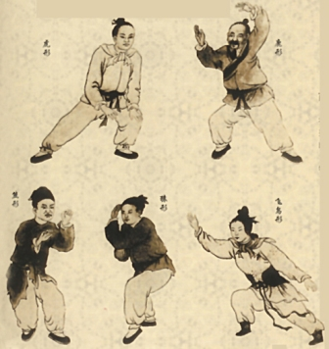
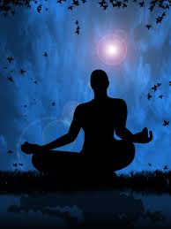
“At the centre of your being
you have the answer;
You know who you are
and you know what you want.”
Lao Tzu
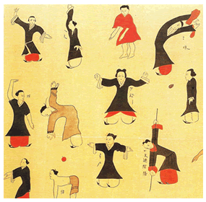
Come to a one day workshop to experience the ancient practices of Qigong and Meditation in a beautiful setting by the beach in Eastbourne. We will be exploring the power of the breath with gentle, flowing movements and stillness, connecting with our own energy and that of nature.
Qigong , derived from the Chinese “qi” and “gong” means working with the life force to develop vitality, strength, and wellbeing. Qigong is also a path to greater self awareness and understanding of our true nature.
Meditation has been practiced for thousands of years and can be done by people of all faith traditions. With the practice of meditation the mind settles and a sense of ease, tranquillity and joy arise. This leads to insight and wisdom.
Date: SUNDAY, 26th JANUARY 2013 Where: At the Natural Fitness Centre, Eastbourne. Time: 10.00am - 4.30 pm. Please bring lunch with you to share. Investment: £45.00. For further details and booking please see below…

Course leaders: Nick Neter, BSC Hons , MRSS, Dip QT
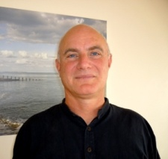
Shiatsu Practitioner and QigongTeacher
handswork@tiscali.co.uk 07773061309
and
Yasmin Shah, MSc, MHSc, MEd, Dip QT
Insight Meditation and Qigong Teacher yasminonsea@gmail.com 07870 975176

